Title with Times New Roman, Font Size: 14, Bold, Alignment Centred Spacing before: 0 pt. Spacing after: 12 pt.
Authors: First Name, Middle Initial, Last Name ¹ (presenting author at the first place), First Name, Middle Initial, Last Name ² (co-author(s))
¹Affiliation of First Author, ²Affiliation of co-author(s)
(Spacing before: 0 pt. Spacing after: 12 pt.)
General Abstract Formatting Guidelines:
- 200-400 words (including references – use “word count” in Microsoft WORD)
- 12-point font, Times New Roman, single-spaced, justify alignment
Figure Formatting Guidelines:
- Figure is optional.
- black and white, resolution: at least 300 dpi
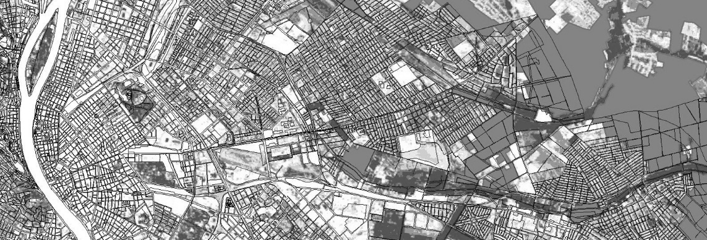
Figure 1. The title of the figure. Font Size: 10, Italic, Alignment Centred Spacing before: 0 pt. Spacing after: 12 pt.
Citation and Reference Formatting Guidelines
- Reference is optional.
- References, Font Size: 10, Alignment: Left, Spacing before: 0 pt. Spacing after: 6 pt.
Greenway Planning: Planning for linear corridors has occurred across multiple scales — national, state or province, and municipal. This track will cover innovations in greenway planning that span research, policy, and practice with a focus on cultural landscape planning, recreational, and ecological corridors (Rebenevic et al., 2009).
Landscape Planning: Planning for new land uses while protecting ecological integrity and ecosystems is the theme for landscape planning. This includes green infrastructure, ecological networks, and urban planning solutions (Maecenas and Tellus 2005).
Maecenas, N. R.; Tellus V., 2005; Sed vitae placerat purus. Aliquam auctor pp. 456
Rebenevic, A.; Catoff, D.; Tamin, E.; Lops R., 2009; Sat Tep Rcenas. Rge UPress, Detidge, UM, and Inhental Zel Uhecred, Fredev (in press)

Authors Biography
- Please provide a brief biography for each author, maximum 100 words for each of the authors (use “word count” in Microsoft WORD)
- 12-point font, Times New Roman, single-spaced, justify alignment
Example:
Robert L. Ryan, FASLA is professor and chair of the Department of Landscape Architecture and Regional Planning, University of Massachusetts, Amherst where he teaches courses on green infrastructure planning and environment and behavior research. His research explores the role of place attachment as a motivation for stewardship of urban green spaces. He is the co-author of the award-winning book, With People in Mind: Design and Management of Everyday Nature (Island Press, 1998), Planning for Climate Change (Routledge, 2018), as well as over thirty-five journal articles and book chapters.

