Title with Times New Roman, Font Size: 14, Bold, Alignment cantered
Spacing before: 0 pt. Spacing after: 12 pt.
First Name, Middle Initial, Last Name ¹ (presenting author at the first place), First Name, Middle Initial, Last Name ² (co-author(s))
¹Affiliation of First Author, ²Affiliation of co-author(s)
(Spacing before: 0 pt. Spacing after: 12 pt.)
The full paper is 6-8 pages long including figures and references. Paper size: Letter. The text should be as here: Times New Roman, Font Size: 12, Regular, Alignment: Justified. Line spacing: Single. Spacing before: 0 pt. Spacing after: 12 pt.
Please use the recommended structure in your full paper if applicable as follows:
(Title of paragraphs Font Size: 12, Style: Bold, Alignment: Left, Spacing before: 18 pt. Spacing after: 12 pt.)

1. Abstract
2. Introduction
3. Background and Literature Review
4. Method and Data
5. Results
6. Discussion and Conclusion
7. References

Tables, Figures:
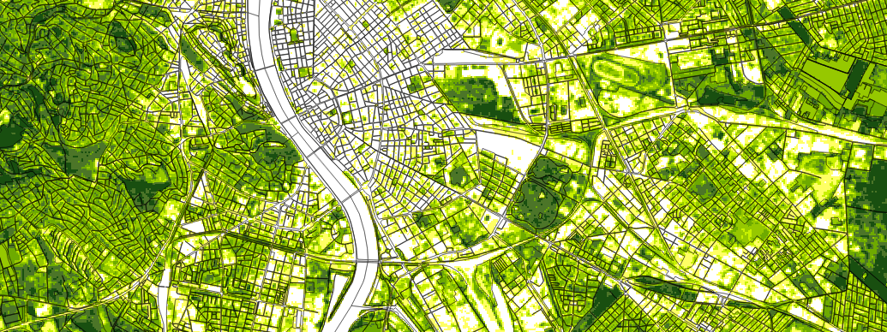
Figure 1. The title of the figure (resolution: at least 300 dpi, Font Size: 10, Bold, Alignment: Centred, Spacing before: 6 pt. Spacing after: 12 pt.)

Table 1. The title of the table (Font Size: 10, Bold, Alignment: Centered, Spacing before: 0 pt. Spacing after: 6 pt.)
 | 1890 | 1950 | 1980 | 2008
Sprawl type 1 | 21 | 31 | 34 | 53
Sprawl type 2 | 13 | 13 | 42 | 64
References:
(Font Size: 12, Style: Normal, Alignment: Left, Spacing before: 0 pt. Spacing after: 6 pt.)
CHICAGO style (https://www.scribbr.com/chicago-style/author-date/)

General format example:
In-text citation: (McGuire 2016)
Reference list: McGuire, Ian. 2016. The North Water. London: Simon & Schuster.

Book Citation
In-text citation: (García Márquez 1988)
Reference list: García Márquez, Gabriel. 1988. Love in the Time of Cholera. Translated by Edith Grossman. London: Cape.

Book Chapter citation
In-text citation: (Stewart 2007)
Reference list: Stewart, Bob. 2007. „Wag of the Tail: Reflecting on Pet Ownership.” In Enriching Our Lives with Animals, edited by John Jaimeson, 220–90. Toronto: Petlove Press.

Journal citation
In-text citation: (Gmuca et al. 2015)
Reference list: Gmuca, Natalia V., Linnea E. Pearson, Jennifer M. Burns, and Heather E. M. Liwanag. 2015.“The Fat and the Furriest: Morphological Changes in Harp Seal Fur with Ontogeny.” Physiological and Biochemical Zoology 88, no. 2 (March/April): 158–66.

Example texts:
…..The success literature of the twentieth century is ‘filled with social image consciousness, techniques, and quick fixes’ (Covey 1989, 18). …..
….. and ecological corridors (Rebenevic et al. 2009). …..
….. urban planning solutions (Maecenas and Tellus 2005). …..
….. planning context (Detl 2002). ….

Example reference list:
Hersperger, A. M., Langhamer, D., & Dalang, T. 2012. Inventorying human-made objects - A step towards better understanding land use for multifunctional planning in a periurban Swiss landscape. Landscape and Urban Planning, 105(3), 307-314. doi - 10.1016/j.landurbplan.2012.01.008
Detl, H. 2002. TepFadels XX1.3c, dowgzable free demo-version: http://esdt4.tuwezi.as.il/ TepFadels/ TepFadels.htm
Maecenas, N. R., Tellus V. 2005. Sed vitae placerat purus. Aliquam auctor pp. 456
Rebenevic, A., Catoff, D., Tamin, E., Lops R. 2009. Sat Tep Rcenas. Rge UPress, Detidge, UM, and Inhental Zel Uhecred, Fredev (in press)
Covey, Stephen. 1989. The 7 Habits of Highly Effective People. New York: Free Press.

