Cultivation under the Framework of the “Balaton Law”
the Effectiveness of the Regional Land Use Plan in the Balaton Recreational Area on the Traditional Cultivation Forms
Krisztina Filepné Kovács ¹, Virág Kutnyánszky ¹, Shi Zhen ¹, Zsolt Szilvácsku ¹, Edina Dancsokné Fóris ¹
¹Hungarian University of Agriculture and Life Sciences, Department of Landscape Planning and
Regional Development Budapest

Abstract
The Balaton region is Hungary's most popular recreational destination, renowned for being home to Central Europe's largest freshwater lake and for its beautiful traditional vineyards and horticulture. For over a century, it has attracted tourists, but following 1990, many vineyards and orchards were abandoned, leading to significant urbanization along the shoreline that threatened the lake's ecological balance.
Our study examines land use changes in the surrounding areas and assesses the effectiveness of the regional land use plan (1990-2018) specifically the 2000 Balaton Law (BKÜRT), aimed at preserving traditional land use and controlling urbanization. This law mandated that construction could only occur if 80% of the vineyard was cultivated.
Using the Corine Land Cover (CLC) database, covering years from 1990 to 2018, we categorized land cover into seven types: artificial/urban, transportation, vineyards, orchards, cropland, grassland, and wetland water surfaces. Despite strict regulations, we observed a concerning trend, with a 35% drop in vineyard areas since 1990, and a shift in regulatory zones of M-2 Horticultural Area, C-1 Vineyard cadastral area. Our findings highlight the challenges and limitations of land use regulations in this region.

Introduction
The Balaton region is the most popular recreational destination in Hungary, not only because it is the largest freshwater lake in Central Europe, but also due to its scenic surroundings of traditional vineyards and horticulture. This area boasts a rich history of viticulture and fruit production, particularly of apples, plums, cherries, and pears. The mild climate around Lake Balaton, combined with the well-drained soils on the surrounding hills of volcanic origin, has traditionally supported the growth of orchards and vineyards. As Balaton has become one of Hungary’s most sought-after tourist destinations, the increasing demand for real estate and tourism development has led to a decrease in available land for agricultural activities, including fruit cultivation and vineyards. There is a significant trend of converting fruit plantations, gardens, and vineyards into recreational and residential areas. This shift is especially noticeable in regions historically in use for horticulture and viticulture, posing a threat to the traditional/agrarian landscape character.

Various studies (Kertész et al 2019; Petrovszki et al 2024) have highlighted the intensive process of suburbanization along the shoreline areas; however, there is a lack of monitoring regarding these developments in the surrounding settlements. Even the ministry has not conducted a thorough assessment of the impacts stemming from the regional land use plan known as the Balaton Law.

Background and Literature Review
The protection of traditional vineyards is a priority in Hungary, as these areas play a crucial role in preserving not only the traditional methods of vineyard cultivation but also the rural landscape and the sustainability of both culture and economy. Additionally, the contribution of vineyards to the character of the landscape is significant, particularly in regions like Balaton, where viticulture has a rich history dating back centuries. Historical records from the 11th century, such as charters, donation letters, and inventories, indicate a common practice: in serf plots, typically around 50 acres, at least one acre was always designated for vineyards (Laposa, 1988).
However, the transformation of traditional vineyards into residential and recreational areas began after the phylloxera epidemic at the end of the 19th century. This epidemic devastated many vineyards, including those in the Balaton Highlands; for instance, the vineyard in Balatonalmádi was replaced by a villa district (Rehák, 2024; Laposa, 1988). More widespread changes commenced during the socialist era (1945-1990), when steep foothill areas were used for smallscale vineyard cultivation while lower-lying areas were converted into intensive vine plantations managed by agricultural associations (Rehák, 2024). Following the shift of small plots into private ownership, these spaces often transitioned from vine cultivation to recreational use (Illés, 2022).
Research examining landscape changes in foothill areas across Europe has yielded results similar to those found in Hungarian regions such as Northern Hungary and the Balaton Uplands (Papadias et al., 2023; Dobos et al., 2016; Incze and Novak, 2016). Due to their transitional nature, foothill areas hold significant potential for protection and development. This includes maintaining biodiversity, preserving the mosaic structure of the landscape and its diverse uses, protecting the character of the landscape with its rich natural and cultural values, and fostering the development of viticulture and wine culture (Dobos et al., 2016).
In response to political changes, urban sprawl and suburbanization intensified after 1990. To combat these negative trends, a stringent regional plan was adopted in 2000 to safeguard the recreational area. This plan is known as the Land Use Regulations of the Balaton Priority Recreational Area under Law 2000 CXII (commonly referred to as the “Balaton Law”). The regulations implemented by this land use plan aimed to preserve traditional land use practices and manage urbanization. Among the various regulations, some were specifically designed to protect and maintain traditional vineyards and orchards, stating that construction would only be permitted if at least 80% of the vineyard was actively cultivated. To address the need for monitoring and evaluating landscape trends and the effectiveness of the Balaton Law, our research objectives were as follows:
- To evaluate land use changes with a focus on the primary cultivation forms, focusing on vineyards and orchards within the Balaton recreational area.
- To assess the impact of spatial plans by comparing the land use zones (specifically the Vineyard Zone and Horticulture Zone) of the Balaton Law with the observed land use changes.

Method and Data
4.1. Method
For the spatial-temporal analysis we used the Corine Land Cover (CLC) database: 1990, 2000, 2006, 2012, and 2018. The CLC Database uses 25 ha as the minimum mapping unit. It is the only data source for the study area that reaches back to 1990. We aggregated the CLC nomenclature, creating seven main types of land cover: artificial/urban, transportation, vineyards, orchards, cropland, grassland, wetland water surfaces.
Theme |  | BKÜTRT 2000 |  | BKTÜRT 2008 |  | BKTÜRT 2018
Cultivation – Horticulture/ | M-2 | Horticultural area | M-2 | Horticultural area | M-2 | Horticultural area
Cultivation  Vineyards | C-1 | I. class vineyard cadastral area | C-1 | Vineyard cadastral area | C-1 | Vineyard cadastral area
Cultivation  Vineyards | C-2 | II. class vineyard cadastral area |  |  | C-1 | Vineyard cadastral area

The Balaton-Law was modified several times, the rules, the spatial extension of the land use zones changed, in our research with GIS techniques we analysed the changes and overlapped them with the results of land use changes. Considering the focus of our research from the wide scale of zones of the BKÜRT 2000 (the original Law had 27 zones which was gradually reduced to 20 with some new zones from the national level land use plan) we analysed the Horticulture zone (M-2) and Zones related to Vineyards C-1 and C-2 (C-1 I. class vineyard cadastral area and C-2 II. class vineyard cadastral areas) The C-2 zone was in 2008 the zone has been eliminated, but in 2018 mostly the same areas were brought back and joined to zone C-1.
4.2. Study area
The Balaton Recreational Area, located around Lake Balaton in Hungary, is one of the most popular tourist destinations in Central Europe. It is known for its scenic beauty, cultural richness, and outdoor activities. With its 596 km² surface area, Lake Balaton is the largest shallow lake in Central Europe. Its mean depth is 3.3 m and the lake is mesoeutrophic (Istvánovics et al., 2007).
The area of the Balaton Priority Resort Area was 4225 km² (including the lake area) until the 2008 expansion, and then increased to 4480 km² (2008) . Considering the area without lake surface (3886 km2) and the 2017 permanent population (271,271 people), the average population density of the resort area is 69.8 persons/ km².
The Balaton Priority Resort Area is located 80 km from the centre of the capital and the farthest point is 183 km away. Considering administrative units, the Balaton Priority Resort Area is very fragmented as it is located in three counties (Somogy, Veszprém, Zala) and three NUTS-2 regions (Southern, Central and Western Transdanubia), which are currently only used for EU statistical regional delimitations. The settlements of the resort area belong to 11 districts as of 2013 (Dombi et al, Long Term Development Concept).
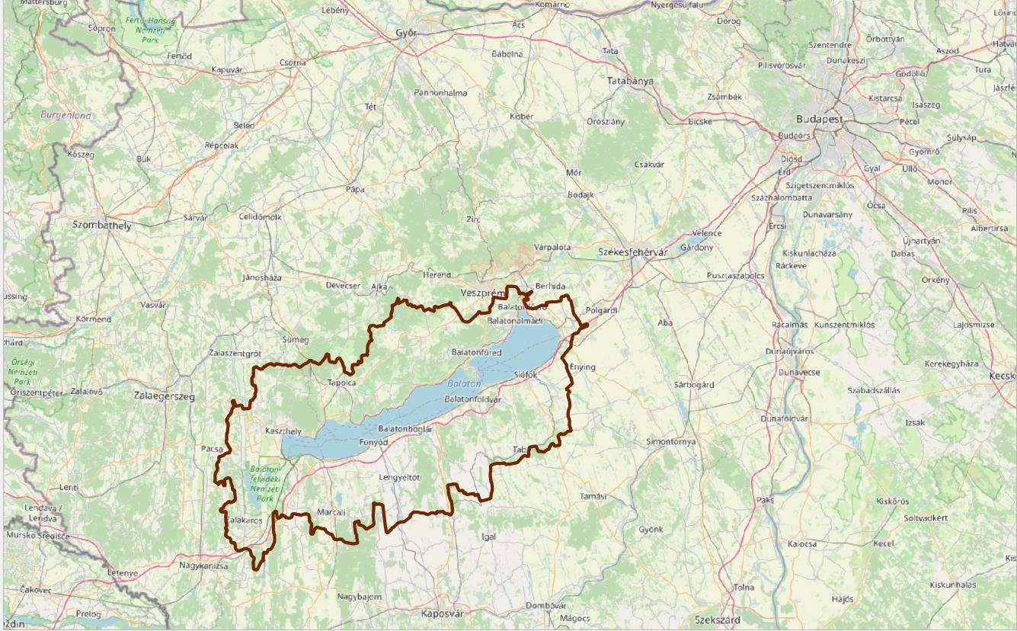

Figure 1. Balaton Priority Resort Area
The economic and social relations of the settlements of the region are significantly influenced by their geographical location and their distance from Lake Balaton. The fundamental territorial specificity of the region is given by the duality of coastal settlements and background settlements. The Act CXII of 2000 (Land Use Plan of the Balaton Priority Resort Area), known as the Balaton Law, formulated different regulations for the coastal and background settlements, however this differentiation doesn’t affect our research focusing on vineyards and horticulture zones. Considering tourism there are extremely large differences between these settlement types. The wave of suburbanisation and urban sprawl firstly hit the coastal settlements and in a much lower rate the background villages, although strong changes started in the background areas as well and recently after the lack of building possibilities around the lake a significant attention is now on the background areas. Considering vineyards, we see a very strong suburbanisation in the slopes overlooking the lake in the former small scale vineyards meanwhile in the background regions vineyards remained more intact.

Results
In our analysis we explored the relation between the regulation zones and the changes of the land use types under protection. One of the most important land use type forming the unique landscape character of the Balaton region is viticulture.
The evaluation of the general land use changes in the analysed region revealed a drastic, 35% drop of vineyards since 1990. The spatial changes of the zones make the comparison difficult, however in the original C-1 zone the share of vineyards decreased from 129,3 km² to 112,5 km² by 2018 (a 13% decrease) and in C-2 we note a 23% decrease. The share of vineyards decreased in both zones. (in the C-1 was 48% which dropped to 42,5% by 2018). The share of vineyards in C-2 was lower even in 2000 just 30,5% which also dropped to 24,5%. There was an almost 50% growth in built up areas and gardens, orchards in the area of C-1 and a 32% growth in shrub or transitional woodland shrub. The area of shrubs doubled and forests grow by 70% in zone C-2 (Figure 2).
Considering the regulation zones there was a significant spatial restructuring, the C-2 zone ceased to exist in 2008 and later its area was more or less retrieved and joined with C-1. So only half of the total zone remained stable (permanent total: 215.52 km²), quite a large area (83.24 km²) was retrieved, furthermore 32.11 km² disappeared completely and 95.68 km² was declared protected later. Summarizing the results by 2018 a larger regulation zone was elaborated however with a lower share of vineyards, so the regulation became less focused and concentrated.

0
50
100
150
200
250
300
350
400
450
CLC
1990
CLC
2000
CLC
2006
CLC
2012
CLC
2018
Other
Water bodies
Wetlands, inland
marshes
Shrubs, transitional
woodland shrub
Grassland, pastures
Forests
Fruit trees, berry
plantations
Vineyards
Arable land
Urban green
Road and ransportation
Industrial or commercial
units
Figure 2. Land cover (km²) of the vineyard zones in the changing Balaton Law (Own editing, Source of data:
European Environment Agency (https://land.copernicus.eu/), Corine Land Cover database (CLC 1990, CLC

2000, CLC 2006, CLC 2012, CLC 2018)
Considering orchards and fruit trees on regional level we see just a small drop (-4,5%) by 2018, however there was a fluctuating trend (1990-2000 with a 20% drop and 2000-2006 22,5% growth) in the first two analysed periods. The Horticultural zone (M-2) was made up by 19% of orchards, 54% of vineyards, 16% arable land, 8% forests. With a quite considerable spatial shift of the regulation zone (approximately half of it remained stable and one quarter was withdrawn and one quarter as newly designated area) the share of the fruit plantations increased to 30,5% and vineyards 39%. It is important to note that especially on Balaton uplands large zone areas were withdrawn. Summarizing the spatial change and shift of the land use zone and land cover changes, the new zone became more focused and concentrated considering orchards and vineyards.

Discussion and Conclusion

Our results revealed a negative trend in vineyard conservation in spite of the strict regulations of the Law. The strictest regulation applied to the land use zone of vineyards however we found a significant change of the regulation zone and the share of vineyards decreased considerably by 2018, so the regulation became less focused and concentrated. The general land use trends were also negative: the analysed region experienced a drastic, 35% drop of vineyards since 1990. Similarly, there were drastic changes considering arable land in the region, however the regulation zone of orchards became more focused and concentrated considering orchards and vineyards.
The Corine database has shown the loss of vineyards, however it couldn’t detect the local scale changes. The Figures (Figure 3.), show that the process of building cottages started already during the socialism period, although the trend become more intensive after 1990. Especially this negative trend was extremely strong in the slopes overlooking the lake.

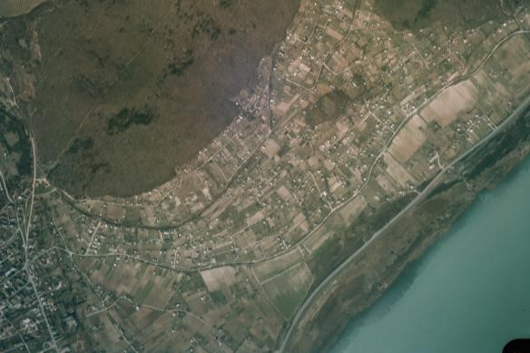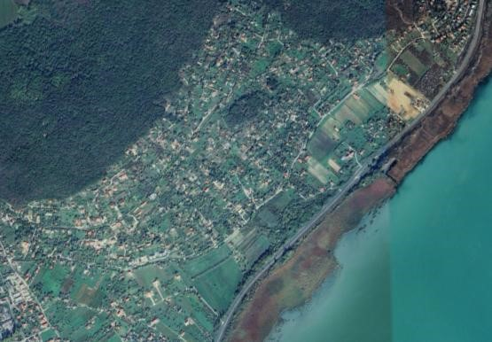

Alsóörs, Aerial photo from 1985, Source: fentrol.hu Present state of the vineyards Source: Google Earth
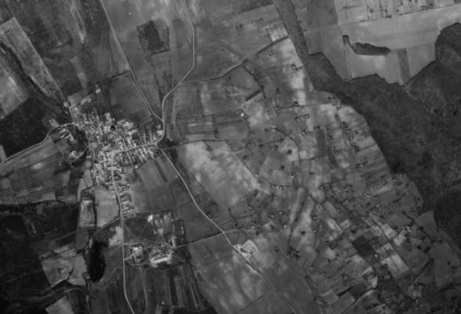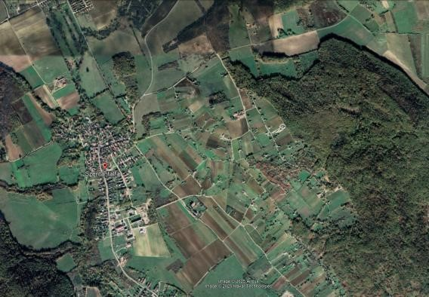

Szentantalfa, Aerial photo from 1971 Present state of the vineyards
Source: fentrol.hu Source: Google Earth
Figure 3. Alsóörs, hillside overlooking the lake, where already for 1985 the landscape changes started and for today become intensive meanwhile in background region vineyards were preserved

In order to stop the negative trends especially in areas still characterized by traditional land use system is it important to apply a more focused, strict and enforceable rules. There is also a need to distinguish between cultivation and recreational purposes. It would be important to regulate the size of buildings more strictly, who owns the land just for recreational purposes must be limited to a maximum building area of 80 square meters (INT-1). It is crucial to review the vineyard zone to identify areas actively maintained by viticulture, avoiding unnecessary conflicts and effectively managing sensitive regions.

7. References

Dombi Gábor, Könczölné Egerszegi Zita, Fekete Károly, Kuborczik Barbara, Molnár Gábor,
Oláh Miklós : A Balaton Kiemelt Üdülőkörzet Hosszú Távú Területfejlesztési Koncepciója 2014 – 2030, Helyzetelemzés /Long Term Development Concept of Balaton Priority resort Area 2014 – 2030, State of the Art
Illés Péter .2022.: Landscape Change and the Transformation of the Socio-Cultural Environment on the Small-Plot Cultivated Vine-growing Hills of South-West Transdanubia, In: Savaria 44 • a Vas megyei múzeumok értesítője 2022 pp. 177–190
Istvánovics, V., Honti, M., Torma, P., Kousal, J., 2022. Record-setting algal bloom in polymictic Lake Balaton (Hungary): A synergistic impact of climate change and (mis) management. Freshw. Biol. 67, 1091–1106. https://doi.org/10.1111/fwb.13903.
József Incze & Tibor József Novák .2016. Identification of extent, topographic characteristics and land abandonment process of vineyard terraces in the Tokaj-Hegyalja wine region between 1784 and 2010, Journal of Maps, 12:sup1, 507-513, DOI: 10.1080/17445647.2016.1195295
Kertész, Á, Nagy, A. L., Balázs B. 2019. Effect of land use change on ecosystem services in Lake
Balaton Catchment In: Use Policy 80, 430–438 https://doi.org/10.1016/j.landusepol.2018.04.005
Laposa József .1988.: Szőlőhegyek a Balaton-felvidéken, Mezőgazda Kiadó, Budapest
Papadias, E.; Detsis, V.; Hadjikyriacou, A.; Papadopoulos, A.G.; Vradis, C.; Chalkias, C. 2023.
Long-Term Dynamics of Viticultural Landscape in Cyprus—Four Centuries of Expansion,
Contraction and Spatial Displacement. Land, 12, 1143. https://doi.org/10.3390/land12061143
Petrovszki, J., Szilassi, p., Erős, T., 2024. Mass tourism generated urban land expansion in the catchment of Lake Balaton, Hungary – analysis of long-term changes in characteristic sociopolitical periods, Land Use Policy, Volume 142, 107185, ISSN 0264-8377, https://doi.org/10.1016/j.landusepol.2024.107185
INT-1 https://24.hu/belfold/2022/09/23/befektetoi-gozhenger-tarolja-le-a-balatoni-szolohegyeket/
Act CXII. of 2000 on Land use plan and Land use regulations of Balaton Priority Resort Area /2000. évi CXII. törvény a Balaton Kiemelt Üdülőkörzet Területrendezési Tervének elfogadásáról és a Balatoni Területrendezési Szabályzat megállapításáról Available: https://njt.hu/jogszabaly/2000-112-00-00
Act LVII of 2008 on the Modification of Act Nr. CXII of the Land use plan and Land use regulations of Balaton Priority Resort Area /2008. évi LVII. törvény a Balaton Kiemelt
Üdülőkörzet Területrendezési Tervének elfogadásáról és a Balatoni Területrendezési Szabályzat megállapításáról szóló 2000. évi CXII. törvény módosításáról Available: https://njt.hu/jogszabaly/2008-57-00-00

8th Fábos Conference on Landscape and Greenway Planning ________________________________________________________________________
Act CXXXIX of 2018 on land use plan of Hungary and priority areas / 2018. évi CXXXIX.
törvény Magyarország és egyes kiemelt térségeinek területrendezési tervéről Available: https://net.jogtar.hu/jogszabaly?docid=a1800139.tv

